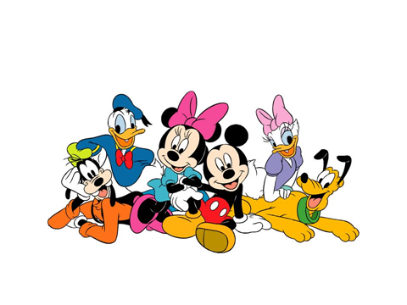ANIMATION
“Animation” is a word that comes from a Latin word “Anima”, which means life. When something is animated, it means that images which are put together seem to come to life. Animation is everywhere ~ movies, TV shows, commercials, and video games.
Part of what makes animation work is that our brains connect the separate pictures into one moving picture ~ it’s kind of like an optical illusion.
In the early days of film animation, every single picture had to be drawn by hand, and it would take hundreds of artists and thousands of pictures to make just a few minutes of a movie. A background was drawn over and over, with slight changes in the characters in each frame. In “Cel Animation”, the background stayed the same, and only the moving portions were changed. Today, most animation is done on computers. There are several different types of animation, but they all use the same basic idea of creating lots of different images and then putting them together in quick motion so that it looks like the characters are moving. Animators create a “storyboard” to plan how the scenes of the movie will go before they start working on the actual animation so that the story and the images will flow together smoothly.
Walt Disney created modern animation and the Disney characters we all know today. He was also the most famous animator in the Unites States, and maybe even the world. Hayao Miyazaki is the most famous animator in Japan, and is also recognized around the world for his “Anime” movies like “My Neighbor Totoro”, “Spirited Away”, and “Howl’s Moving Castle”.
“Toy Story” (1995) was the first full-length animated movie to be created completely in “CGI” (Computer Generated Imagery), which makes the characters seem even more real because we can see them in a more 3-dimensional form.
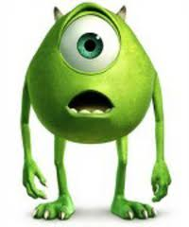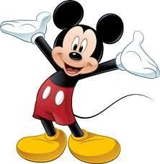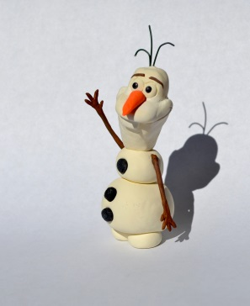
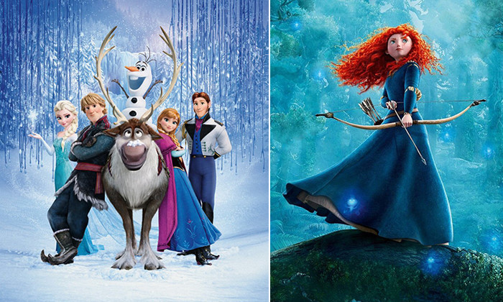
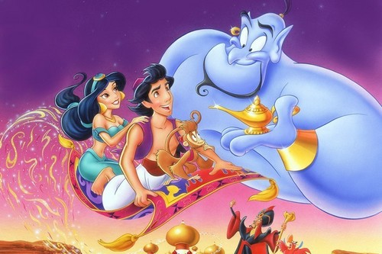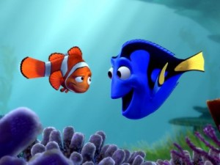
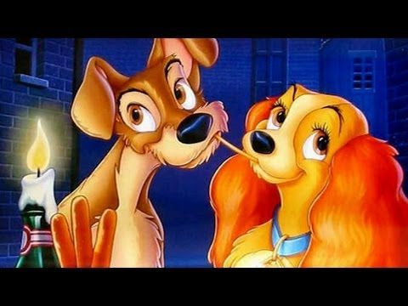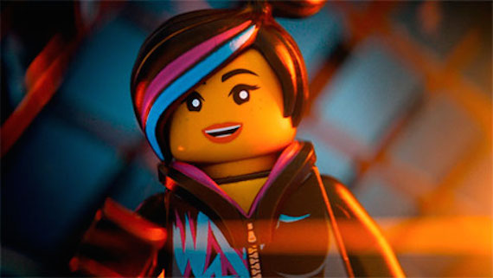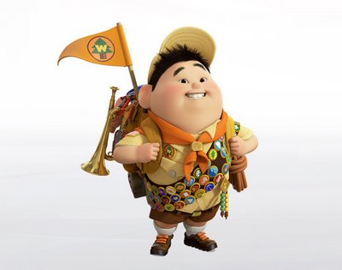

Try This At Home
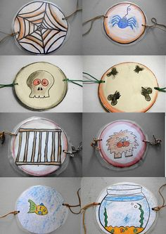
Make A “Thaumatrope”
A “Thaumatrope” is an animation toy that moves two pictures faster than your eyes and brain can separate them. As a result, two separate pictures appear to blend into one.
The way you draw your picture affects what you see. It’s important to line the two pictures up so that they look like one picture when they move. Depending on what you draw, you may have to make the picture on the back upside-down for it to look correct when you spin the disc.
You will need a medium-sized circle cut from a piece of strong paper or cardboard, two rubber bands, a hole punch, and some pencils or markers.
Here are some ideas:
