PAUL GAUGUIN
Post-Impressionist Painter
1848-1903
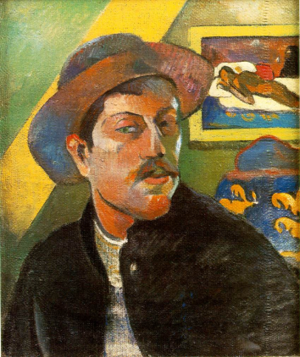
Paul Gauguin was a French artist, born in Paris, which was the heart of the art world at the time. He joined the Navy when he was 17, and didn’t really start painting until he was about 25, while he was a stock broker and a banker. He liked to collect art, and could afford to buy paintings from his artist friends like Camille Pissarro and Paul Cezanne.
He began as an Impressionist painter, but later he developed his own style. Gauguin loved to travel, and lived in France, Peru, and on several tropical islands in his life, but he loved the island of Tahiti best. While he was there, he painted the people and the peaceful world he saw, and these are the paintings for which he is most famous. His ways of combining colors and forms inspired a lot of other artists. Many people didn’t appreciate Gauguin’s art until years after he had died, but today he is recognized as one of the fathers of modern art.
Paul was a good friend of another famous Post-Impressionist painter named Vincent Van Gogh. They painted together and talked a lot about art. They respected each other’s talents and admired each other’s work, but they sometimes argued about the best way to paint.
Gauguin once said “If we look carefully, we will enjoy endless pleasure.”
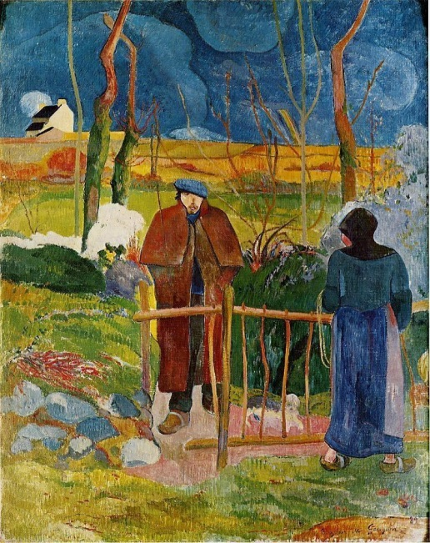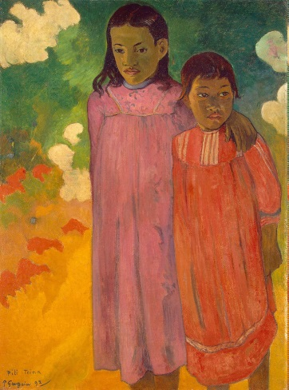
Bonjour Mr. Gauguin Two Sisters
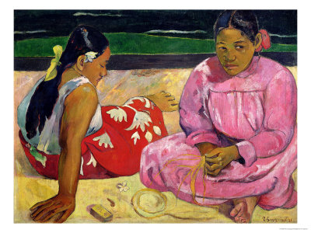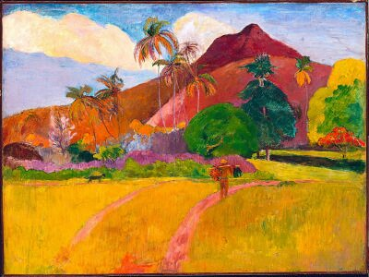
Women of Tahiti Tahitian Landscape
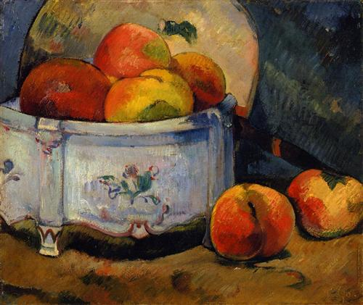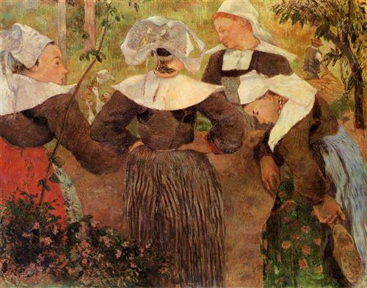
Still Life With Peaches Four Breton Women

