Michelangelo Buonarroti
(1475-1564)
“The Greatest Artist Who Ever Lived”
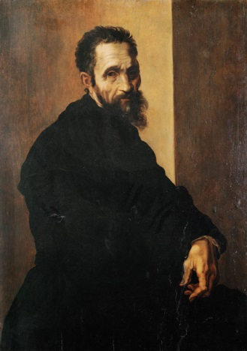
Michelangelo Buonarroti lived and worked in Italy during a time known as “The Renaissance”, which means “rebirth”. People in Europe, and especially in Italy, began to look back on and celebrate Greek and Roman ideas.
Wealthy “patrons” paid artists to create paintings and sculptures for them and their cities. Michelangelo was a painter, sculptor, architect and poet, and he studied science and nature as well ~ a real “Renaissance Man”!
Michelangelo learned stone cutting at a young age and created his first sculpture, “The Pieta” when he was 23. “David”, his most famous sculpture, showed not only the strength of a young man, but also the strength of Florence.
Pope Julius II asked Michelangelo to paint the ceiling of the Sistine Chapel in Saint Peter’s Basilica in Rome. It took him four years to complete, and he worked 60 feet high on a wooden scaffold to paint the frescoes, which are made by mixing paint with wet plaster to make a long-lasting piece of art. One of the things that made Michelangelo such a great artist was his ability to give a special energy and strength to the figures he painted and sculpted.
Michelangelo said:
“Every block of stone has a statue inside it, and it is the task of the sculptor to discover it.”
and
“To know each other is the best way to understand each other, and to understand each other is the only way to love each other.”

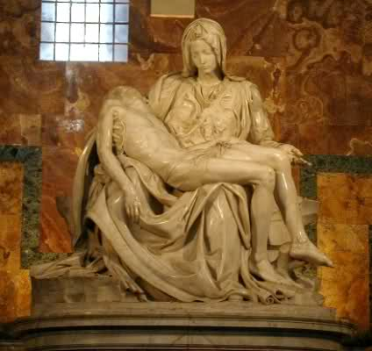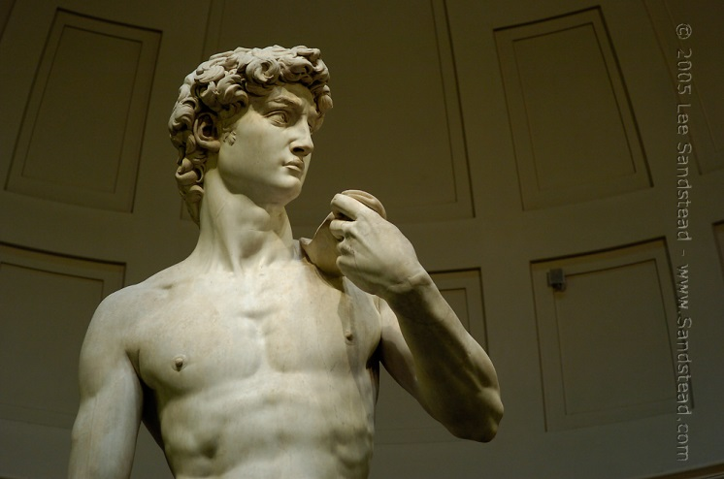
The Pieta Statue of David
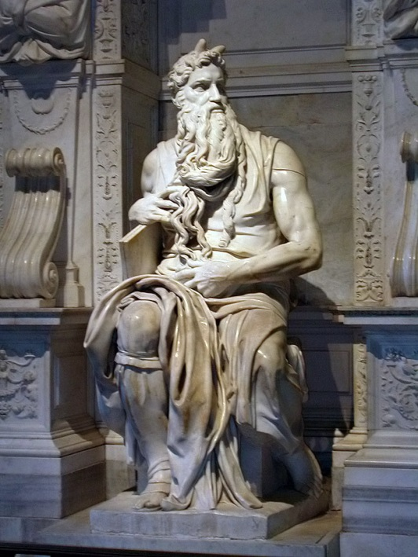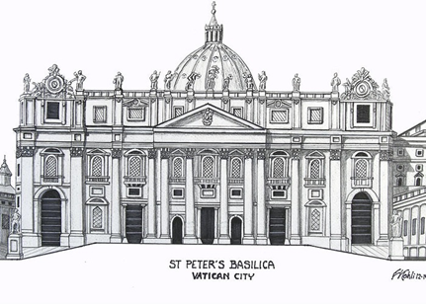
Moses The Dome at St. Peter’s Basilica

Part of the Sistine Chapel Ceiling
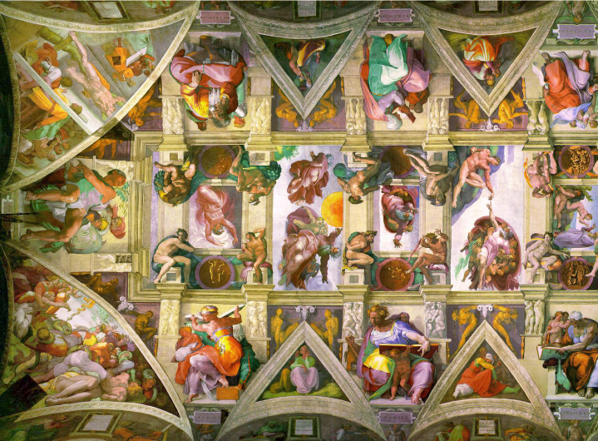

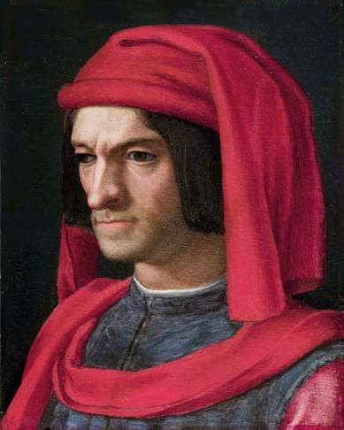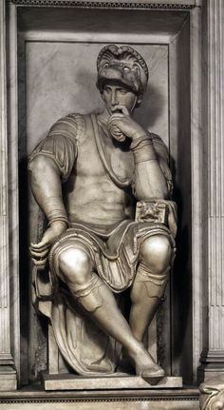
Lorenzo de Medici ~ Michelangelo’s “Patron” Sculpture for Lorenzo

